Basic configuration of Locus Map

Based on Locus Map Pro. Free version might not have some functions.

1. Three lines are the Main menu. Enter it.  
   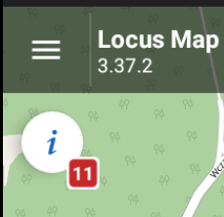
2. Select Settings  
   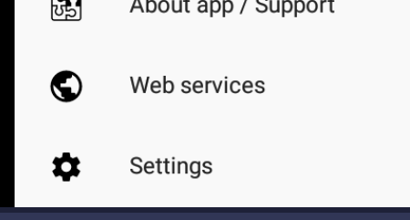
3. Using Language & Units set Language to English
4. Exit Settings and restart an application  
   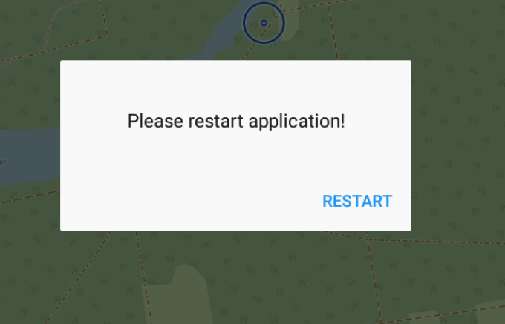
5. Go to Main menu and Settings  
   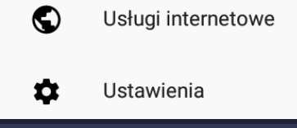
6. Controlling > Map Screen > Enable measurement with two fingers
7. Maps > Auxiliary Graphics > Enable Distance Circles, Cursor to position line and Heading line
8. Maps > Advanced features > Enable Map color mode  
   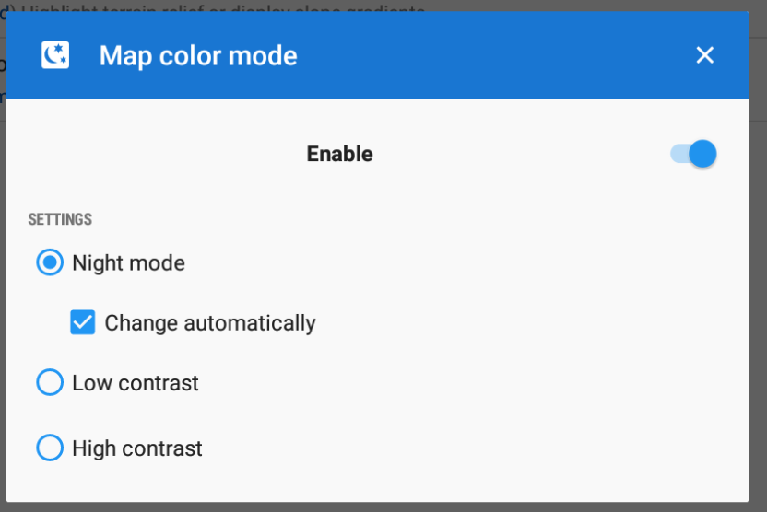
9. GPS & sensors> Compatibility mode (in case of GPS issues)
10. Language & Units > Enable MGRS and metric system
11. Miscellaneous > Enable Run locus Map as service
12. How properly configured app should look like  
    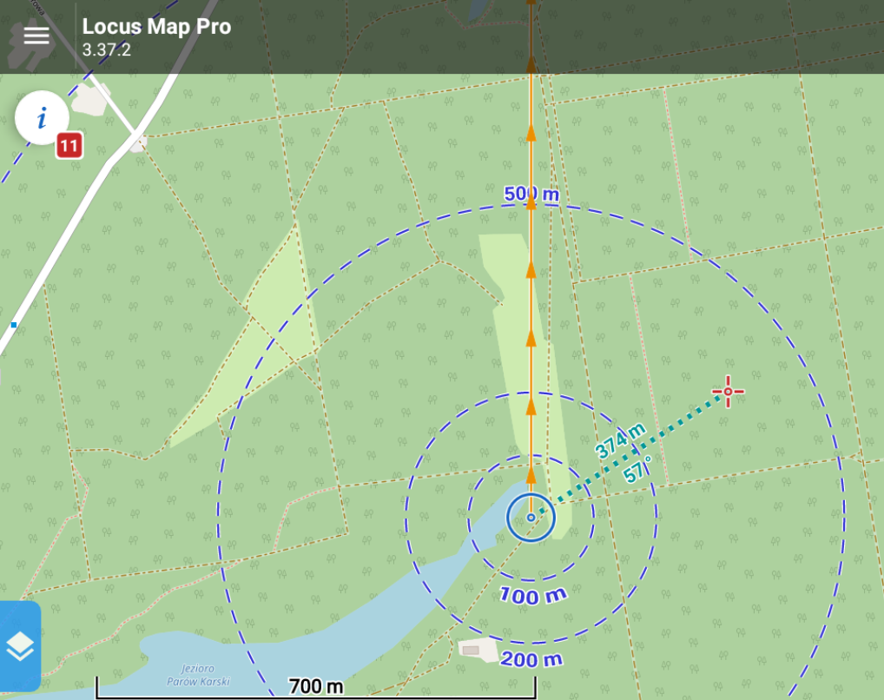
13. Click “Locus Map Pro” and select Coordinates  
    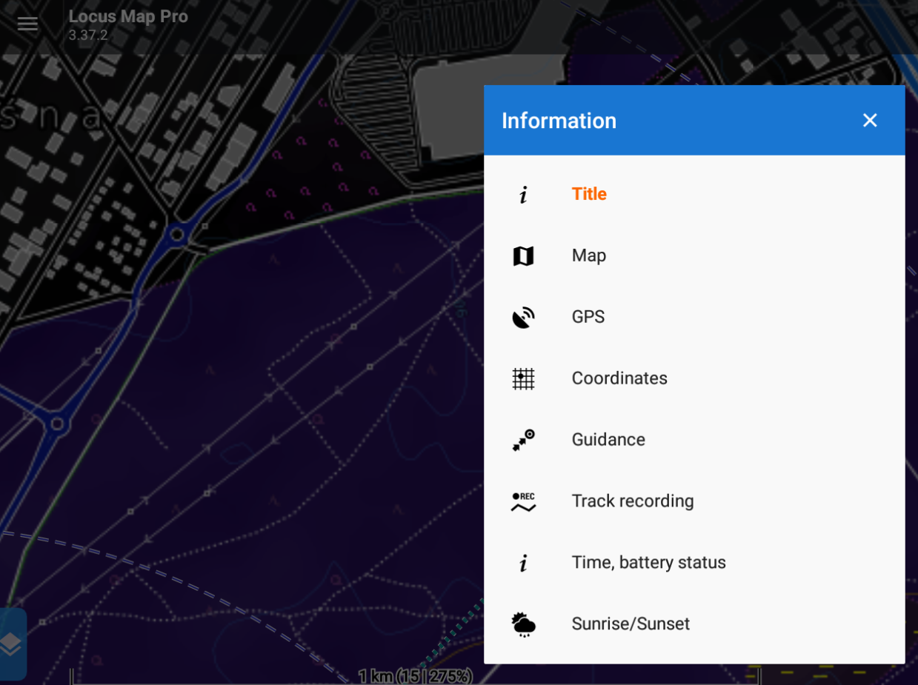
14. Screen configuration  
    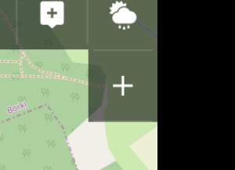
15. Add function to panel 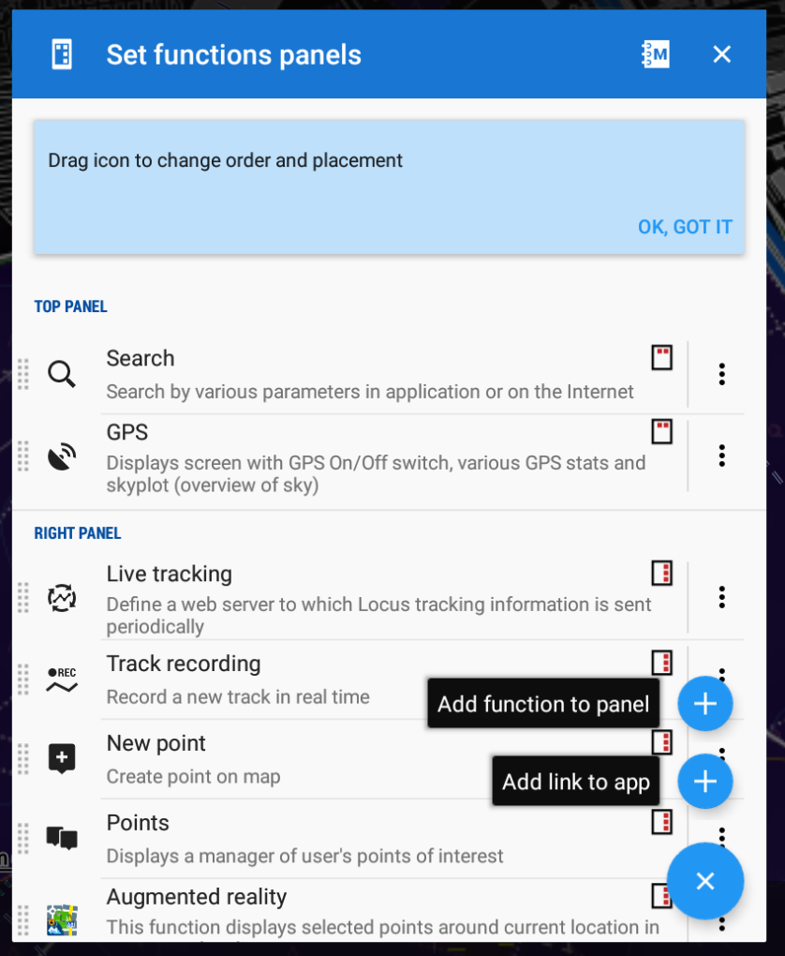
16. Klick Points function  
    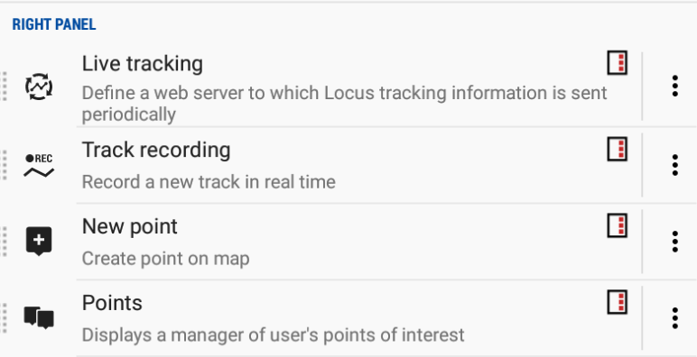
17. Drag 10-point icon and drag to desired position (above Set functions panels)